**STEPPER MOTOR**

**What is Stepper motor?**  
Stepper Motors are brushless DC motors which allow more control to user than normal DC motors or Servo Motors. It is because Stepper Motors move in small steps, so it allows user to have very precise angle. This precise movement also allows them to have very precise speed. Also, they have a very high torque even at very low speeds. But they do not have a feedback mechanism as in Servo motors. So, they can be only precisely aligned from their current position.

**How Stepper Motor works?**

Stepper motor consists of a magnetized core surrounded by coils. There are usually two coils which are winded into smaller coils. By controlling the current to coils we can precisely control the movement of shaft. Suppose, initially our shaft is in the position as shown in the first figure as the top coil is energized. Now, when we change the supply of current from top coil to the other coil then, the shaft is attracted towards this coil as it acts as an electromagnet.

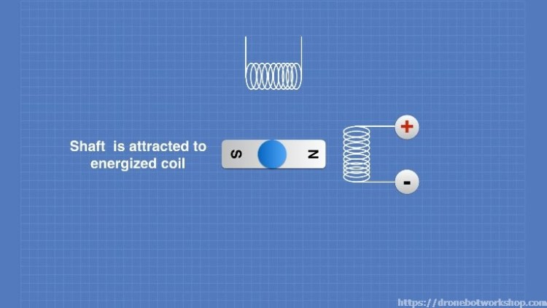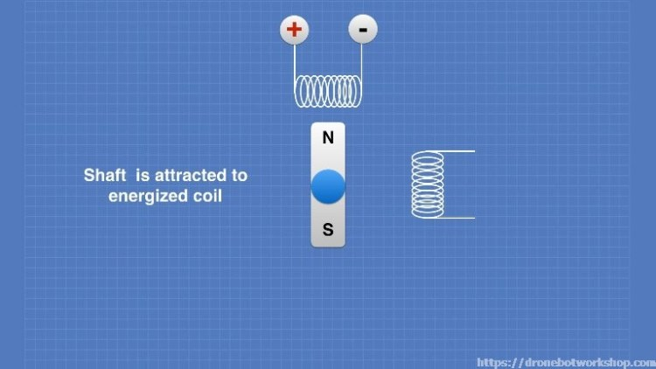

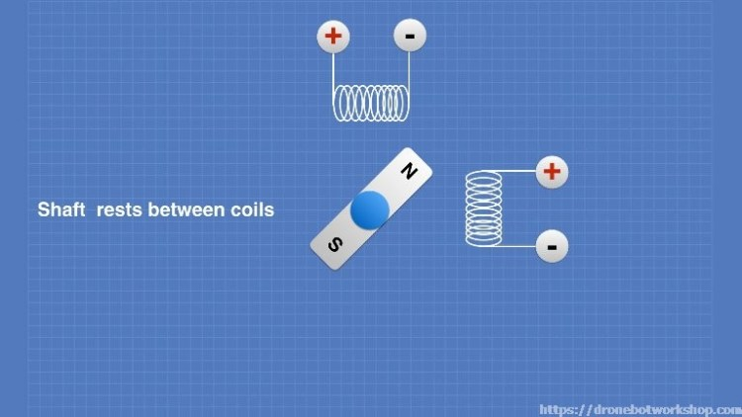This changing of current allows us a movement of 90 degrees. Now for a more precise positioning, we allow current to both the coils. Suppose we apply equal current to both the coils, then the shaft will be placed in between both the coils as shown in the figure. We can align the shaft in any position between the coils by adjusting the current ratio in the coils.

**What are different types of Stepper Motors?**

**Bipolar Stepper Motor**

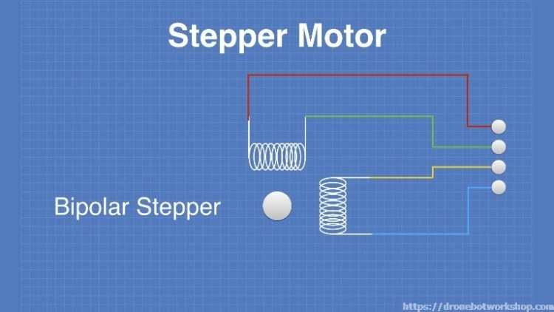They are motors with two coils and four connections. These motors are more efficient as the whole coil is used. But it requires complex drivers as we have to reverse the current polarity to rotate in reverse direction.

**Unipolar Stepper Motor**

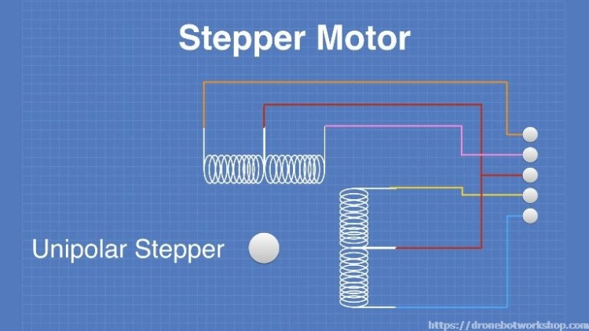These are motors with two coils but the coils have center tap. So, there are total six connections. Usually the center taps are internally connected and set to positive voltage.

Now, the shaft’s position can be changed by just providing negative voltage to one side of a coil. The main advantage of unipolar stepper motor is to rotate it in reverse direction there is no need to change the current polarity, instead negative current is applied to the other side of the coil. The different positions can be obtained in unipolar motor in the similar way as it was done in bipolar motor, i.e., by controlling the current ratio in both coils.

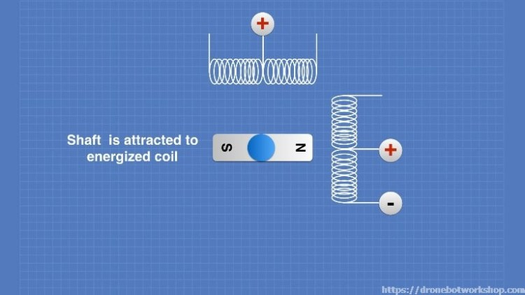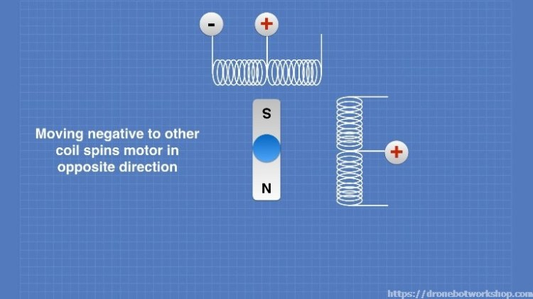

**WIRE CONFIGURATION**

|  |  |
| --- | --- |
| **Wire Color** | **Description** |
| Red | 5V supply voltage |
| Orange | Coil 1 |
| Pink | Coil 2 |
| Yellow | Coil 3 |
| Blue | Coil 4 |

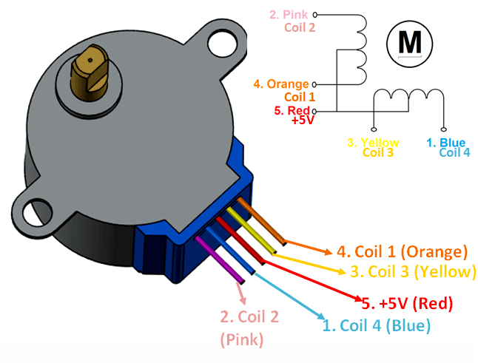

**What is ULN2003?**

It is a driver which is used to drive unipolar stepper motors. Motor drivers are used because motors cannot be directly controlled by microcontrollers as they cannot meet the current requirement of motors.

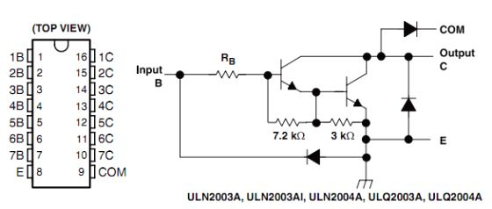**How ULN2003 works?**

ULN2003 consists of seven Darlington Pairs, where each pair can drive load up to 50V and 500mA. The circuit of one pair is shown in the figure. When the input signal is set high, then the output is connected to ground. In a unipolar motor, the center tap is already set to high, to control it we just need to apply ground to one end of coil, so ULN2003 does this for us.

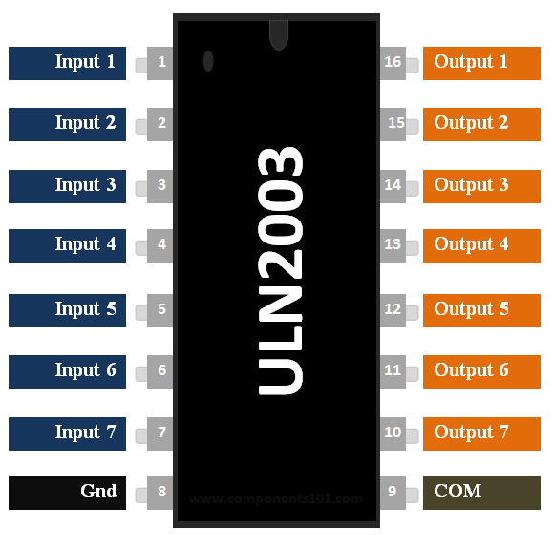**PINOUTs**

|  |  |  |
| --- | --- | --- |
| **Pin Number** | **Pin Name** | **Description** |
| 1 to 7 | Input 1 to Input 7 | Seven Input pins of Darlington pair, each pin is connected to the base of the transistor and can be triggered by using +5V |
| 8 | Ground | Connected to Ground |
| 9 | COM | Used as test pin (optional to use) |
| 10 to 16 | Output 1 to Output 7 | Respective outputs of seven input pins. Each output pin will be connected to ground only when its respective input pin is high(+5V) |

**Some More Specification**

|  |  |
| --- | --- |
| Maximum Voltage Load on each Darlington pair | 50V |
| Maximum Current Load on each Darlington Pair | 500mA |
| Maximum Input Voltage | 30V (usually 5V is used) |
| Operating Temperature Range | -20 to 70°C |